
Lab Title
LED Interfacing and Control Using Microcontroller (Blinking, Sequential, Binary Counter, Traffic Light)
Submitted By:
Khurram Iftikhar
ID NO:
37438
Submitted To:
Sir Safee
Lab No:
04
Program:
BSCS
Submission Date:
12/12/2025

Objectives
- To understand basic GPIO configuration for controlling LEDs.
- To implement simple LED blinking using delay functions.
- To create sequential LED patterns (running LEDs).
- To simulate binary counting using LEDs.
- To design a traffic light system with proper timing sequences..

Tools / Software Used
- Microcontroller / ATmega32
- Proteus
- Microchip Studio
- LEDs
- 330Ω and 10k resistors
- Jumper wires

Procedure and Observation

Task 1:

Simple LED Blink→Understand basic GPIO configuration and delay functions
Explanation:
- Configure one LED as output.
- Turn the LED ON and OFF using delays.
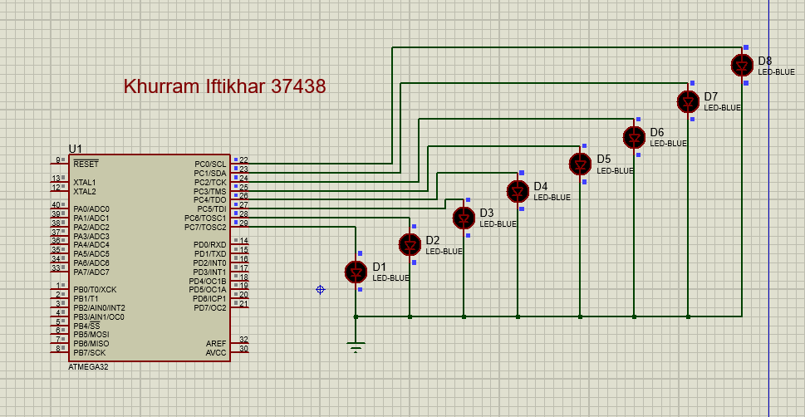
Code:
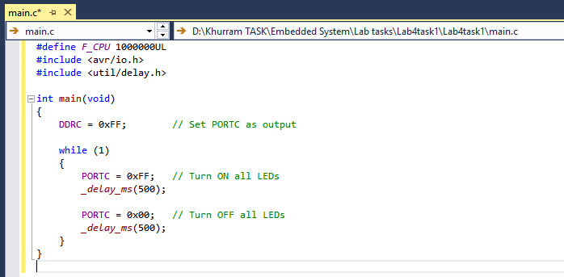

Task 2:
Running LEDs (Sequential LEDs) → Learn to control multiple LEDs and create
sequential patterns.
Explanation:
- Multiple LEDs are connected on PORTx.
- LEDs turn ON one by one to create a running effect.
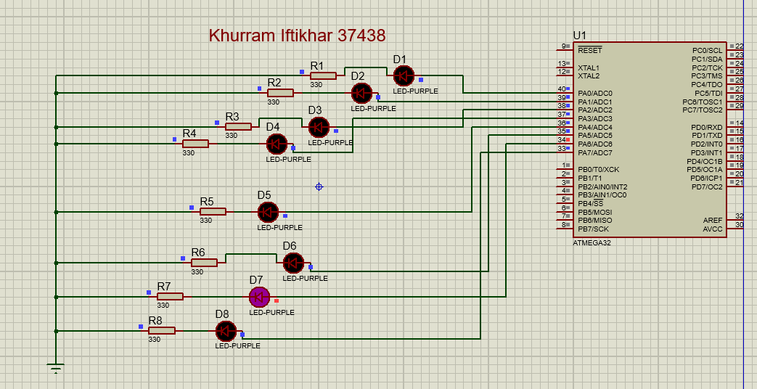
Code:
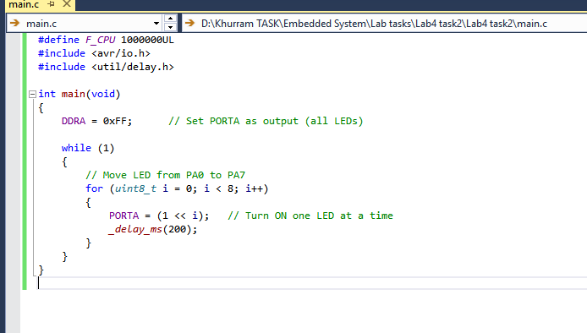

Task 3:
Binary Counter on LEDs → Display binary counting using 4 or 8 LEDs.
Explanation:
- Four or eight LEDs are connected to a microcontroller port.
- The code increments a binary value, and LEDs show the count visually.

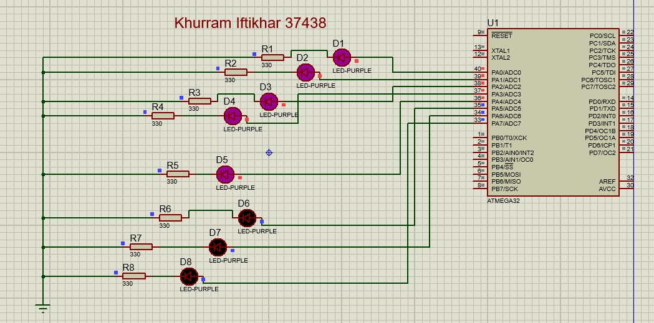
Code:
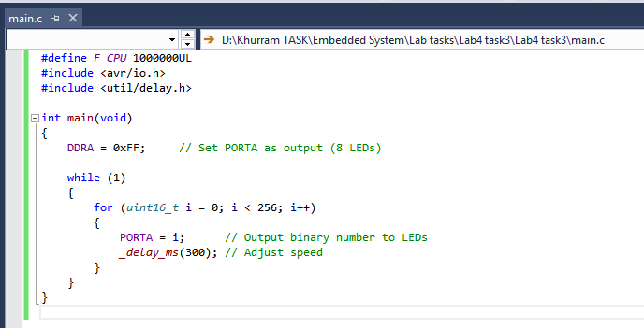

Task 4: Traffic Light Simulation →Implement a real-world application with timing
sequences.
Explanation:
- Three LEDs (Red, Yellow, Green) form a traffic signal.
- Delays control the timing of each light to simulate real traffic flow.
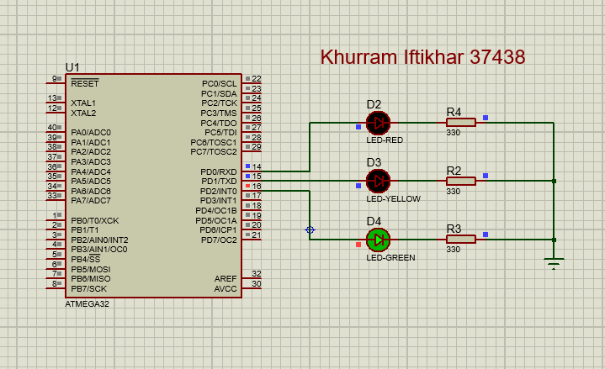
Code:
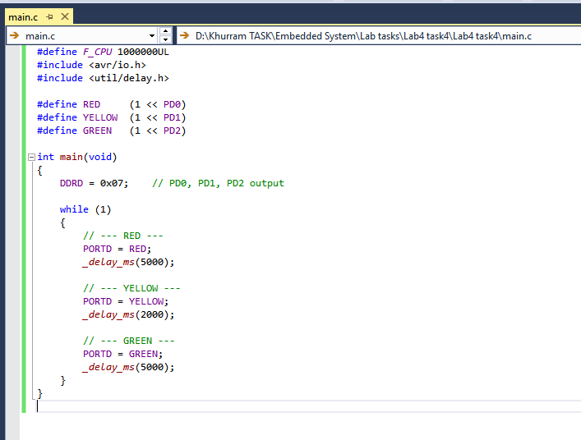

Traffic Light Timing Observation
Light | Duration | Meaning
Green | 5 seconds | Go
Yellow | 2 seconds | Slow down
Red | 5 seconds | Stop

Results
- LED blinking was successfully implemented.
- Sequential LED pattern worked correctly.
- Binary counter displayed accurate binary values using LEDs.
- Traffic light simulation reflected real-world timing and transitions.

Conclusion
This lab provided hands-on experience with LED interfacing and GPIO programming. All tasks demonstrated how microcontrollers control external hardware using port manipulation and delays. The concepts learned here form the foundation for larger embedded system projects.

